PDDS-DS04-IU2-4-RENGARAJALU VINITHA

Designing a pipeline for the Diabetes Dataset in Azure ML Studio

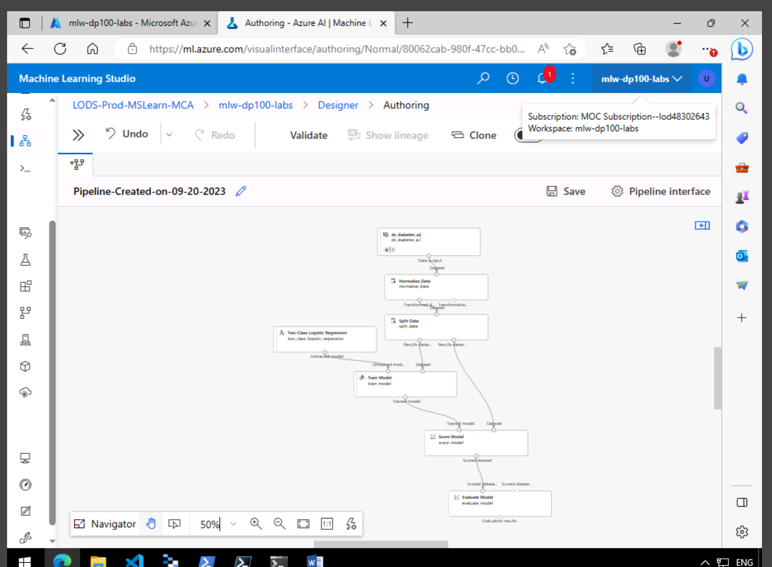

Submitting The Pipeline Job

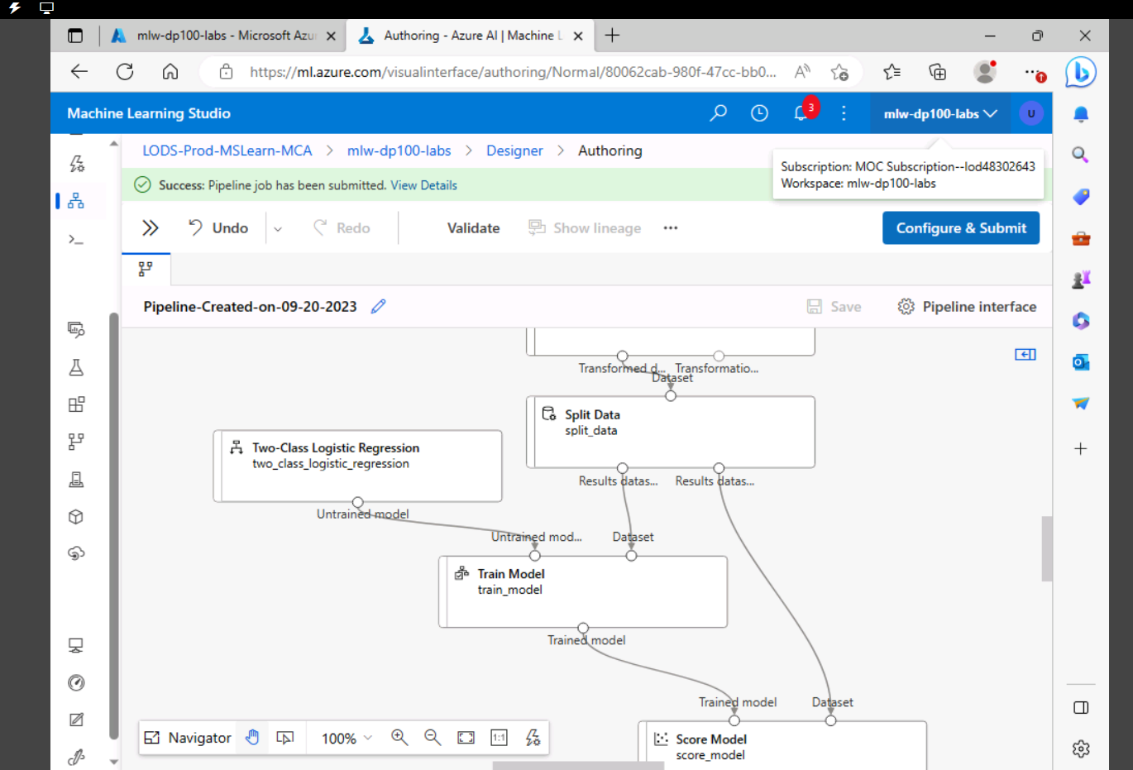

Pipeline Job is reporting as Completed

